

**Lab task 4**

**CS 4-1 BSCS DATABASE**

**Name:** Sharaiz Ahmed **SAP:** 57288

**[Task 1]**

SELECT sal, job

FROM emp

WHERE sal > 4000 OR job = 'MANAGER';

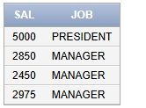

SELECT DEPTNO, LOC

FROM DEPT

WHERE LOC = 'Argentina' OR DEPTNO = 40;



**[Task 2]**

SELECT EMPNO, SAL

FROM EMP

WHERE DEPTNO NOT IN (50, 80);

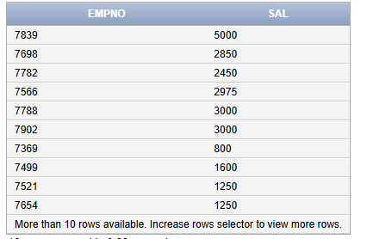

SELECT * FROM EMP

WHERE job NOT IN ('IT_PROG', 'AC_ACCOUNT');

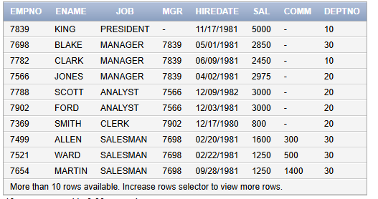

**[Task 3]**

SELECT *

FROM EMP

ORDER BY ENAME DESC, JOB DESC, EMPNO DESC;

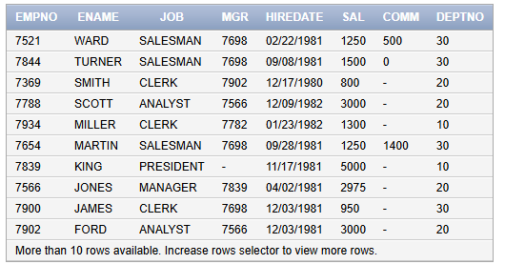

**[Task 4]**

SELECT CONCAT(ENAME, EMPNO) AS FULL_NAME

FROM EMP

WHERE ENAME LIKE 'M%'

AND SAL IN (6000, 1250, 8600, 6100);

